CYBERSECURITY INCIDENT MANAGEMENT SYSTEM

## **Introduction:**

# This paper outlines the development of a robust Cybersecurity Incident Management System (CIMS), beginning with stakeholder engagement and research, followed by meticulous design and iterative prototyping. Implementation integrates diverse tools, custom workflows, and automation for efficient incident response. Rigorous testing, training, and phased deployment ensure functionality and user proficiency. Continuous evaluation, compliance, and incident trend analysis are prioritized for ongoing refinement, serving as a roadmap for organizations to enhance cybersecurity resilience and asset protection.

# **Objectives:**

The primary objectives of implementing this CSIMS cybersecurity incident management system project

1.Incident Detection: Develop mechanisms to detect cybersecurity incidents promptly and accurately, leveraging both automated tools and manual monitoring.

2.Response Time Reduction: Minimize the time between incident detection and response to mitigate potential damages and reduce the impact on the organization.

3. Incident Classification: Establish a clear classification system for different types and severity levels of cybersecurity incidents to prioritize response actions effectively.

4. Documentation and Logging: Implement robust logging and documentation procedures to record all incidents, response actions taken, and outcomes for analysis, compliance, and future reference.

# 5. Response Plan Development: Create comprehensive response plans outlining step-by-step procedures for addressing various types of cybersecurity incidents, tailored to the organization's specific needs and infrastructure.

# **Conclusion:**

In conclusion, a robust cybersecurity incident management system is essential for organizations to effectively detect, respond to, and mitigate the impact of cybersecurity incidents. By prioritizing objectives such as incident detection, response time reduction, incident classification, documentation and logging, and response plan development, organizations can establish a proactive and resilient security posture. Through continuous improvement, training, and integration of threat intelligence, organizations can enhance their incident response capabilities, minimize disruptions to operations, and protect sensitive assets from evolving cyber threats. By addressing these key objectives, organizations can bolster their resilience against cyber attacks and ensure the continuity and security of their operations in today's increasingly complex threat landscape.

## **AIM AND PRIORITY OF THE PROJECt:**

To create a web based gui management system for cyber security incidents made by victims in various platforms. All the values are to be updated and handled in the database using dbsqlite connectivity

## **ARCHITECTURE AND TECHNOLOGY USED :**

### **Frontend Technologies:**

1. **HTML**:
   * No specific version as HTML5 is the current standard.
2. **CSS**:
   * Use CSS3 for the latest features and standards.
3. **Bootstrap**:
   * **Latest Version**: Bootstrap 5.3
   * **Requirements**:
     + A modern browser that supports CSS3 and HTML5.
     + jQuery is not required for Bootstrap 5.
4. **JavaScript**:
   * **Latest Version**: ECMAScript 2024 (ES13)
   * **Requirements**:
     + Modern browsers supporting the latest JavaScript features.
     + Optional: Babel can be used to ensure compatibility with older browsers.

### Backend Technologies:

1. **Django**:
   * **Latest Version**: Django 4.2 (LTS)
   * **Requirements**:
     + Python 3.8 or newer.
     + Virtual environment (optional but recommended for dependency management).
2. **SQLite**:
   * **Latest Version**: SQLite 3.43.1
   * **Requirements**:
     + Included with Python by default.
     + Suitable for lightweight database needs and development environments.

### Additional Dependencies:

* **Django REST framework** (if building an API):
  + **Latest Version**: Django REST framework 3.15
  + **Requirements**: Compatible with Django 4.2
* **Django Templates**:
  + Use built-in Django template engine or third-party options like Jinja2.

# Installation and Setup:

Setting Up Django with SQLite:

Python Installation: Ensure Python 3.8 or later is installed. You can download it from python.org.

Django Installation:

pip install django

Creating a Django Project:

django-admin startproject dbmsproject

cd dbmsproject

Setting Up SQLite: SQLite is included with Python, so no additional setup is required. Django uses SQLite by default.

Starting the Development Server:

python manage.py runserver

Adding Bootstrap to Your Project:

Include Bootstrap in your HTML files via CDN:

<link href="https://stackpath.bootstrapcdn.com/bootstrap/5.3.0/css/bootstrap.min.css" rel="stylesheet">

<script src="https://stackpath.bootstrapcdn.com/bootstrap/5.3.0/js/bootstrap.bundle.min.js"></script>

Alternatively, download Bootstrap and include the files locally.

JavaScript Integration:

Include your custom JavaScript files in your project. Ensure they are referenced in your HTML templates.

<script src="{% static 'js/custom.js' %}"></script>

For advanced JavaScript functionality, consider using frameworks or libraries such as React, Angular, or Vue.js.

# DESIGN

Entity Relationship Diagram:

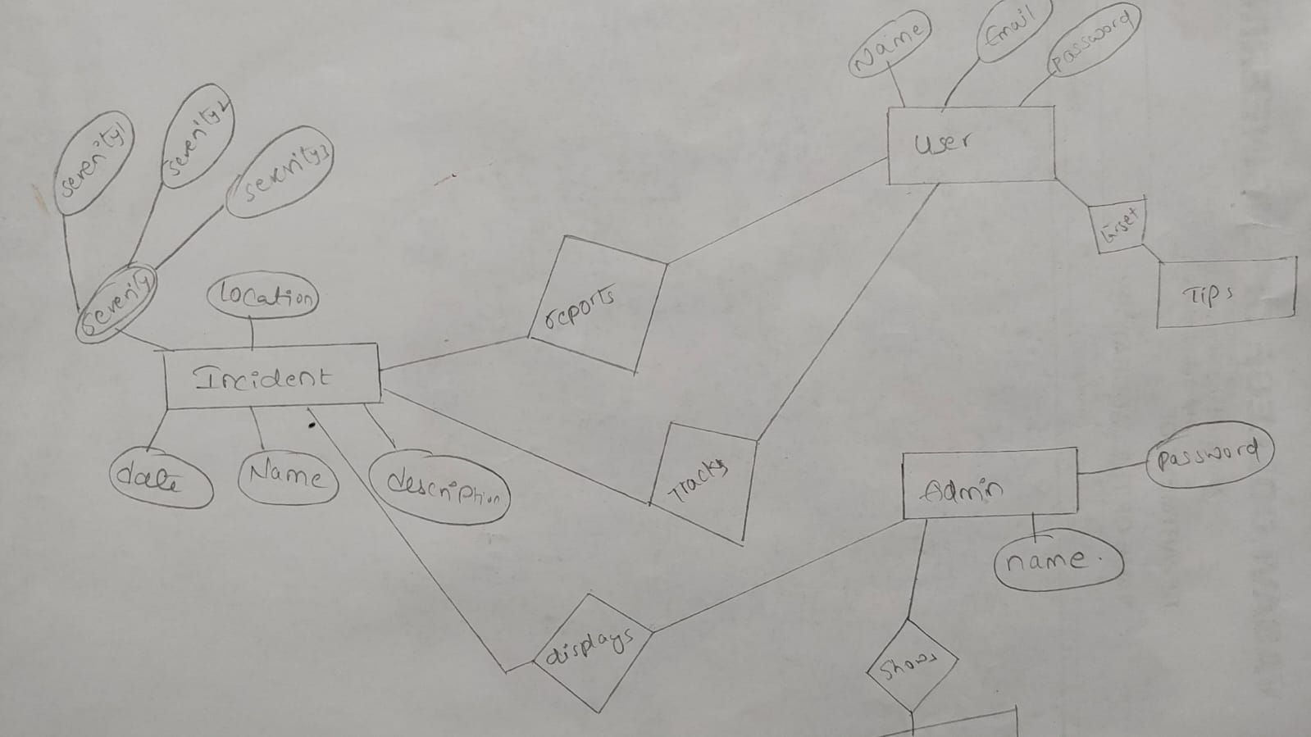

Here user can report the incident according to the severity level of the cyber incident.

# Project Structure:

# 

**:**

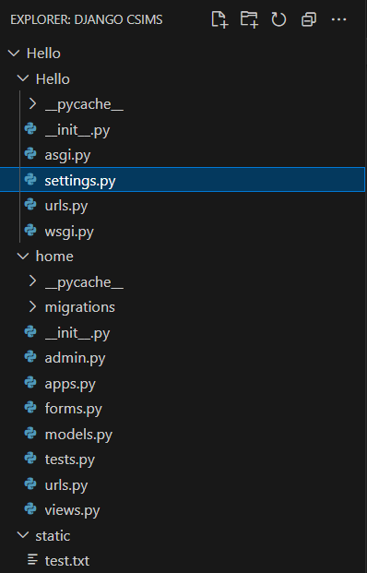

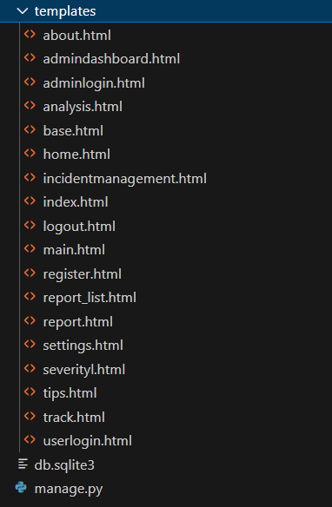

OUTPUTS: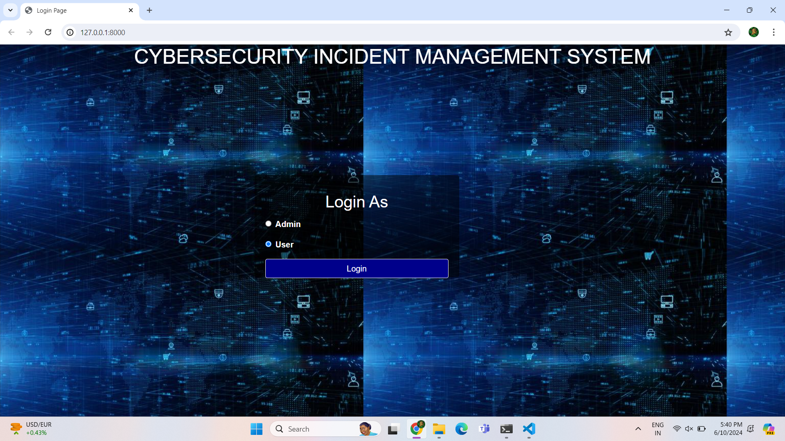

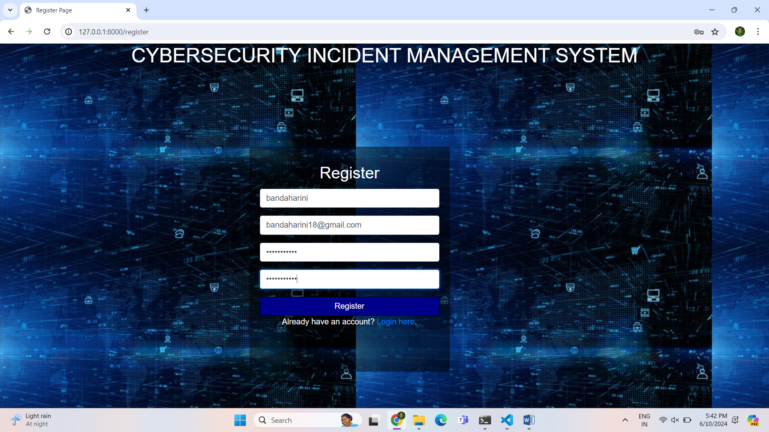

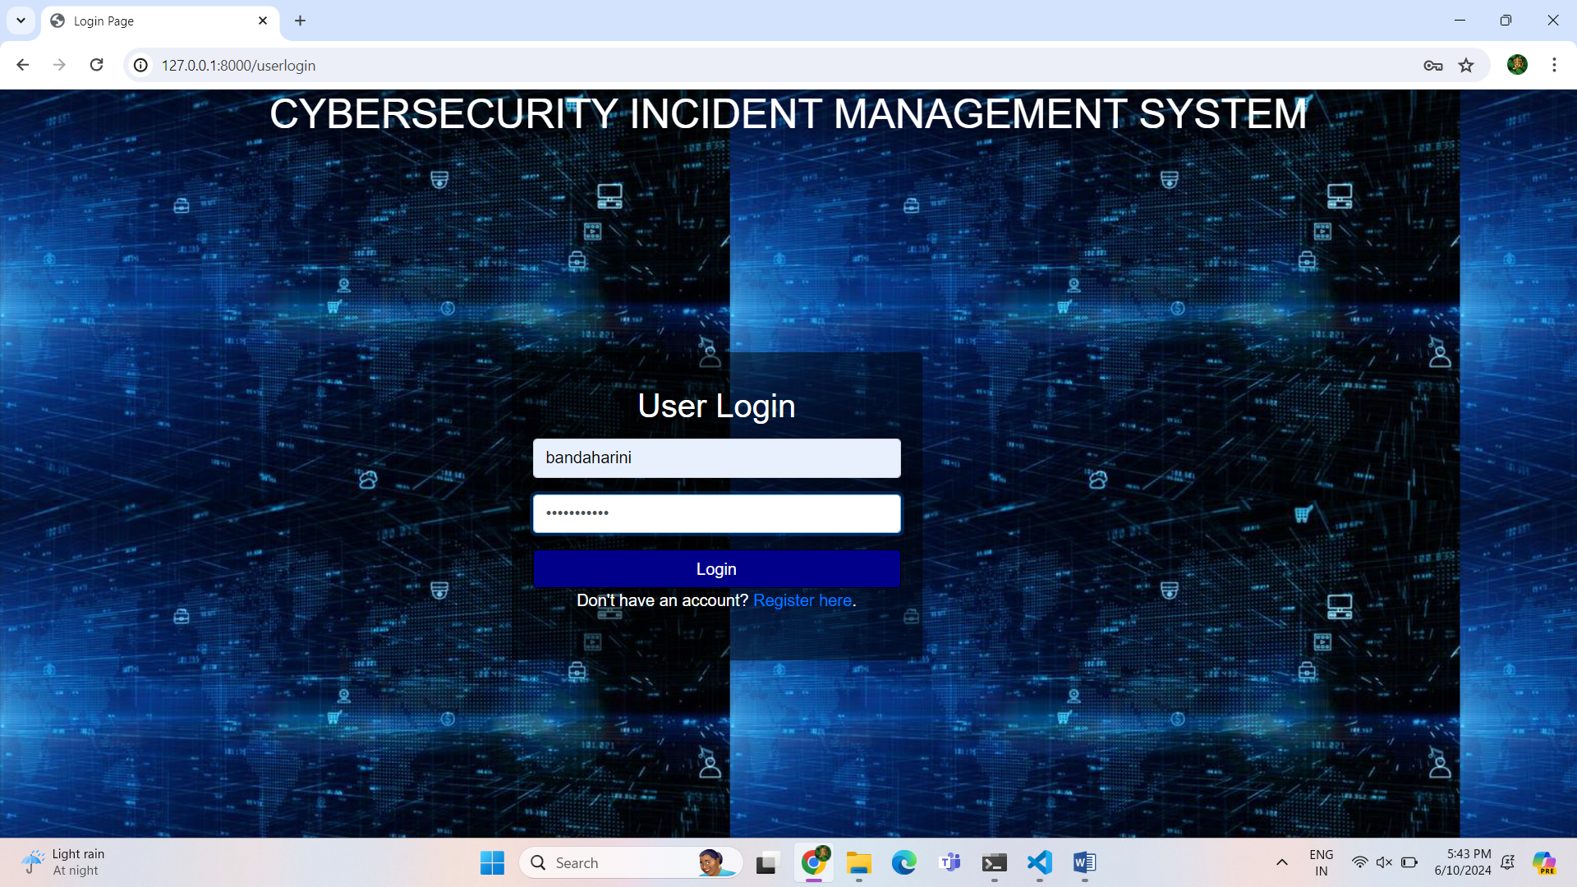

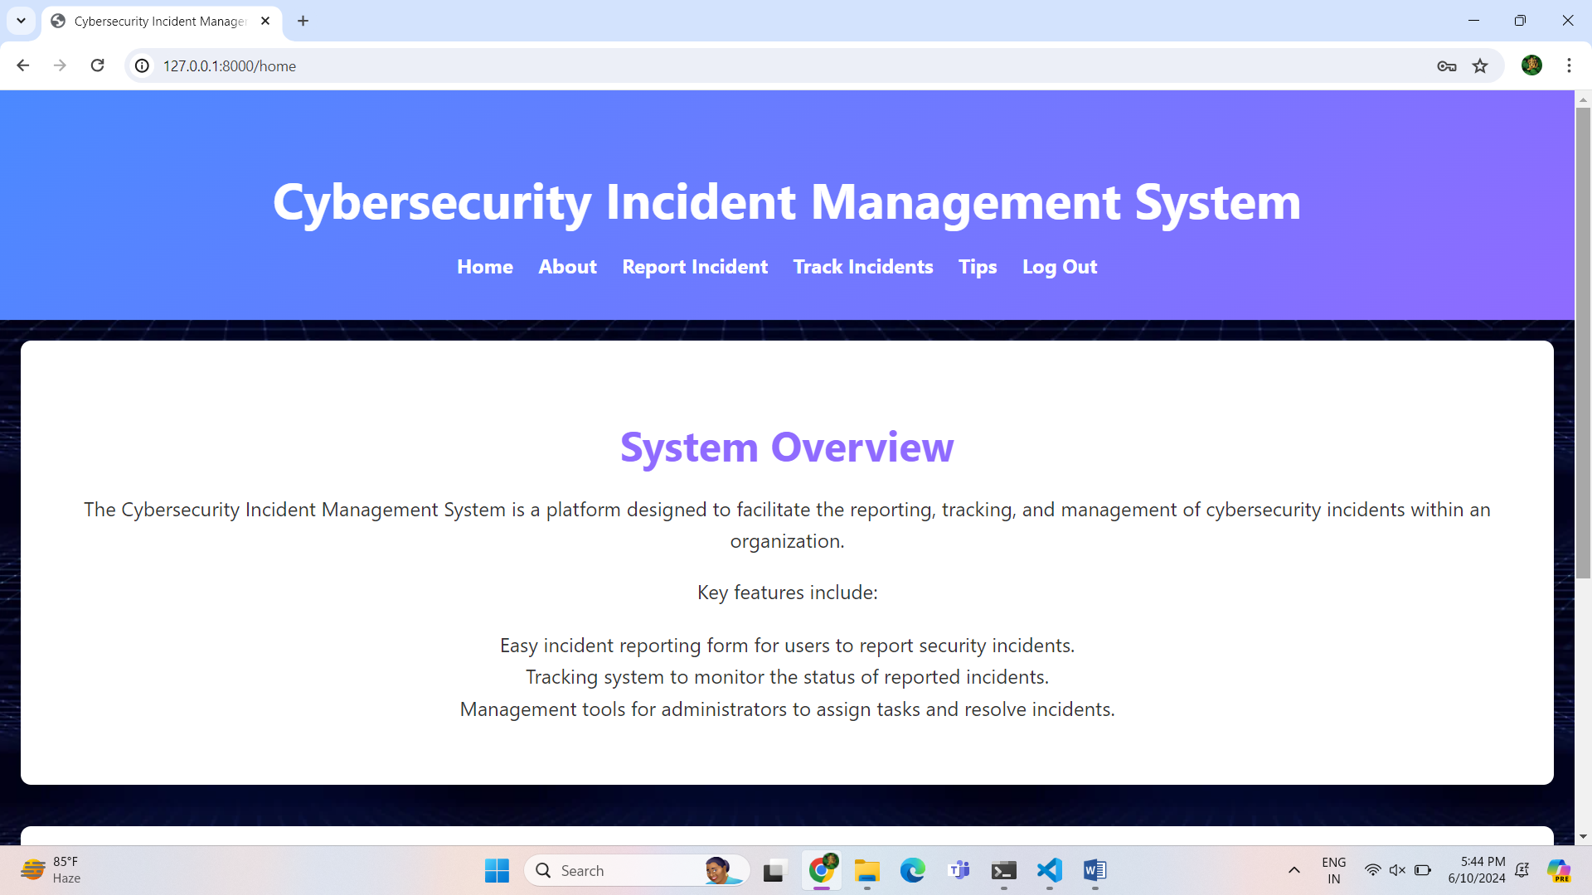

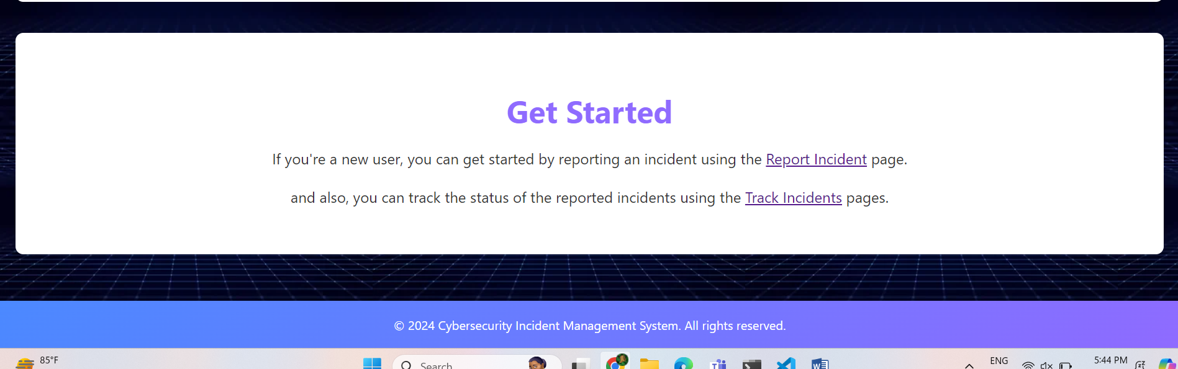

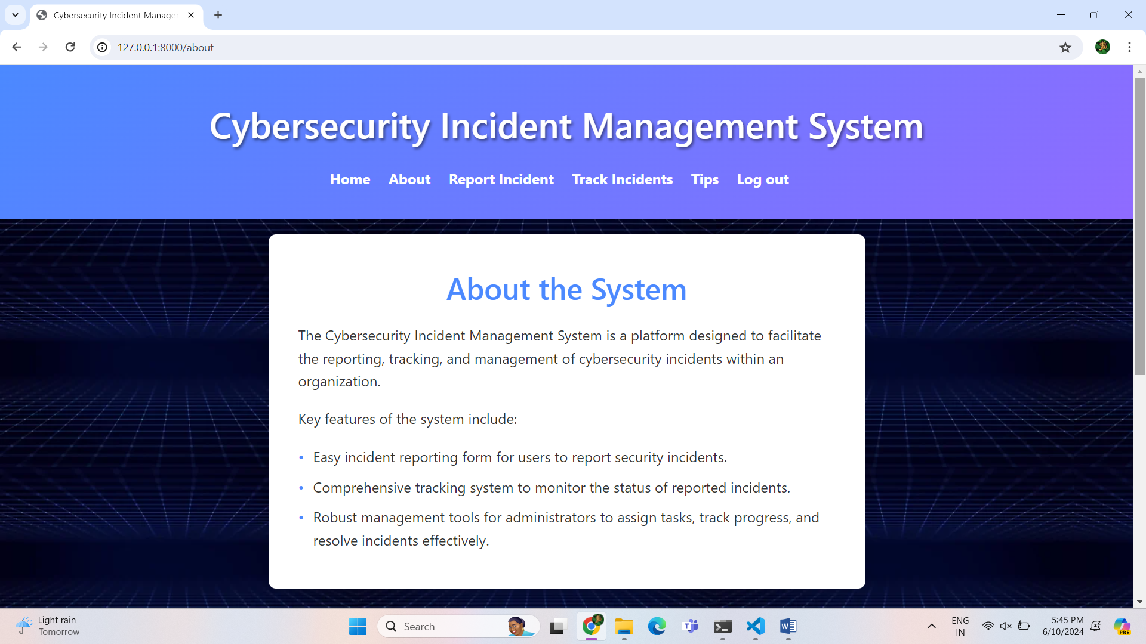

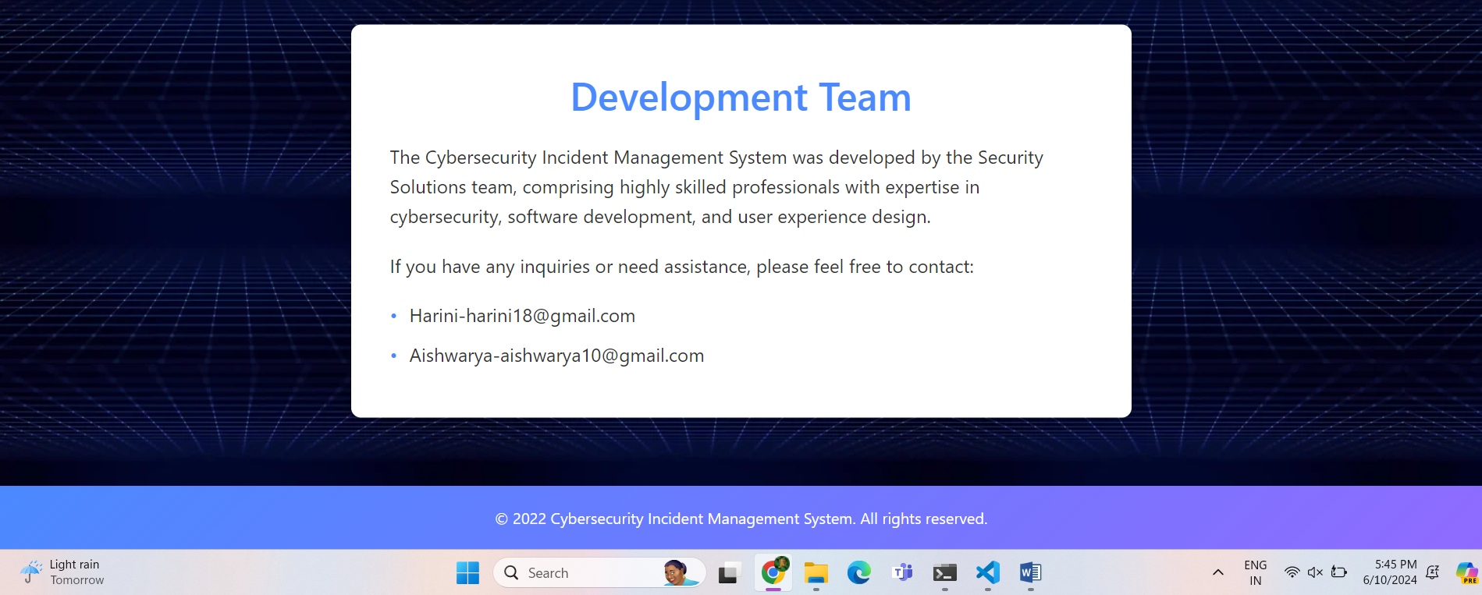

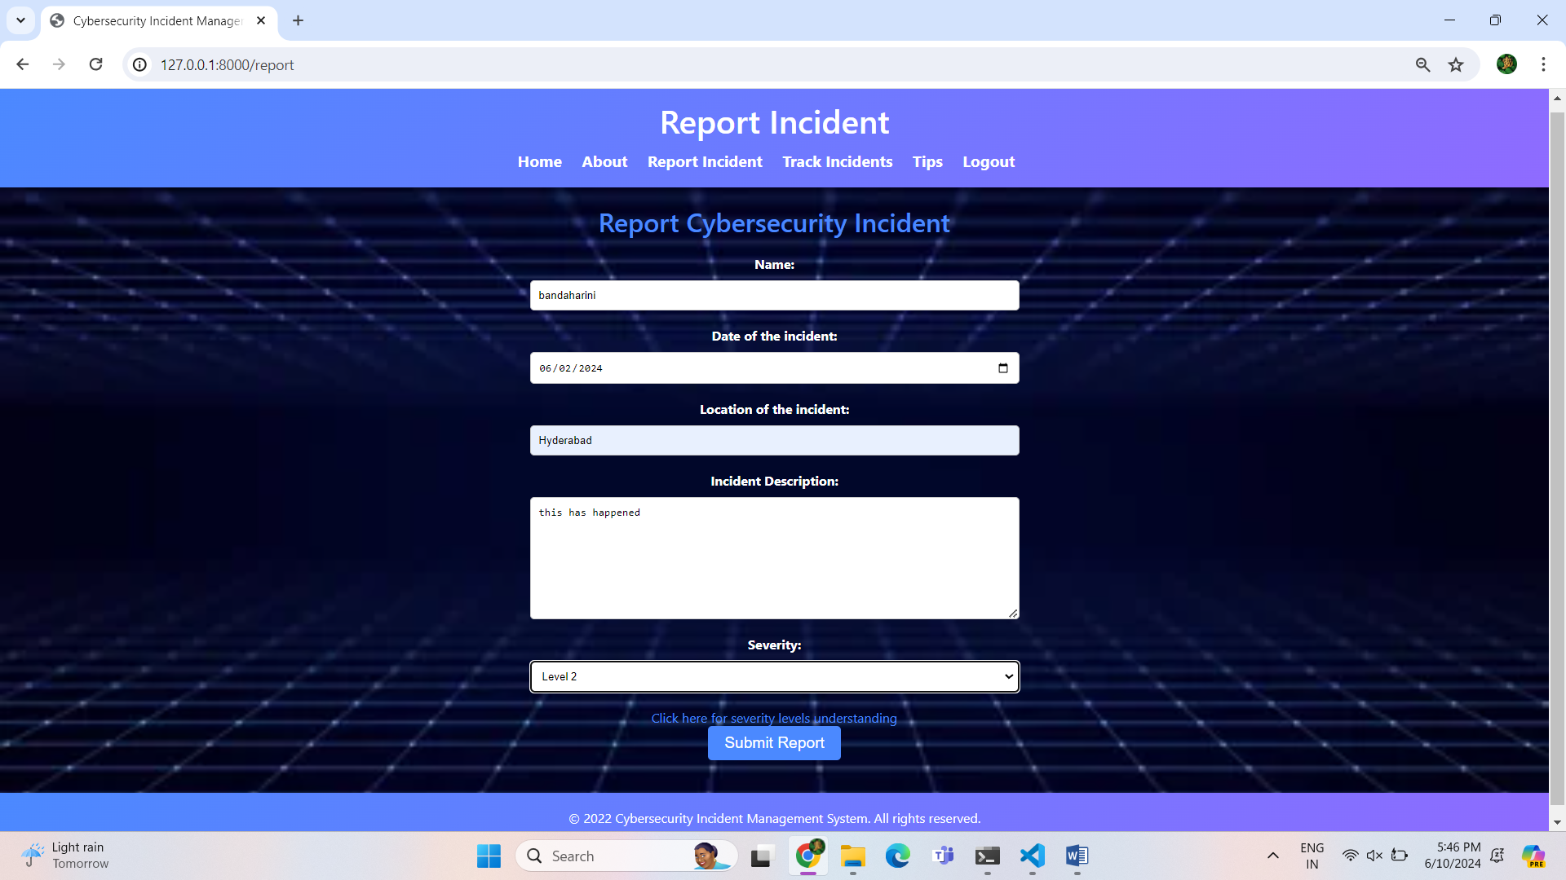

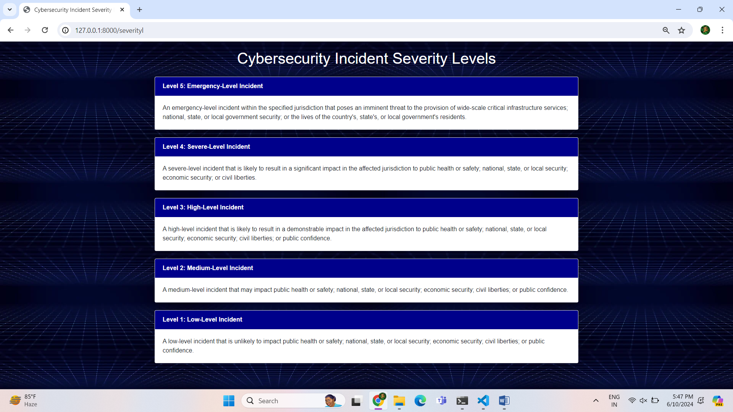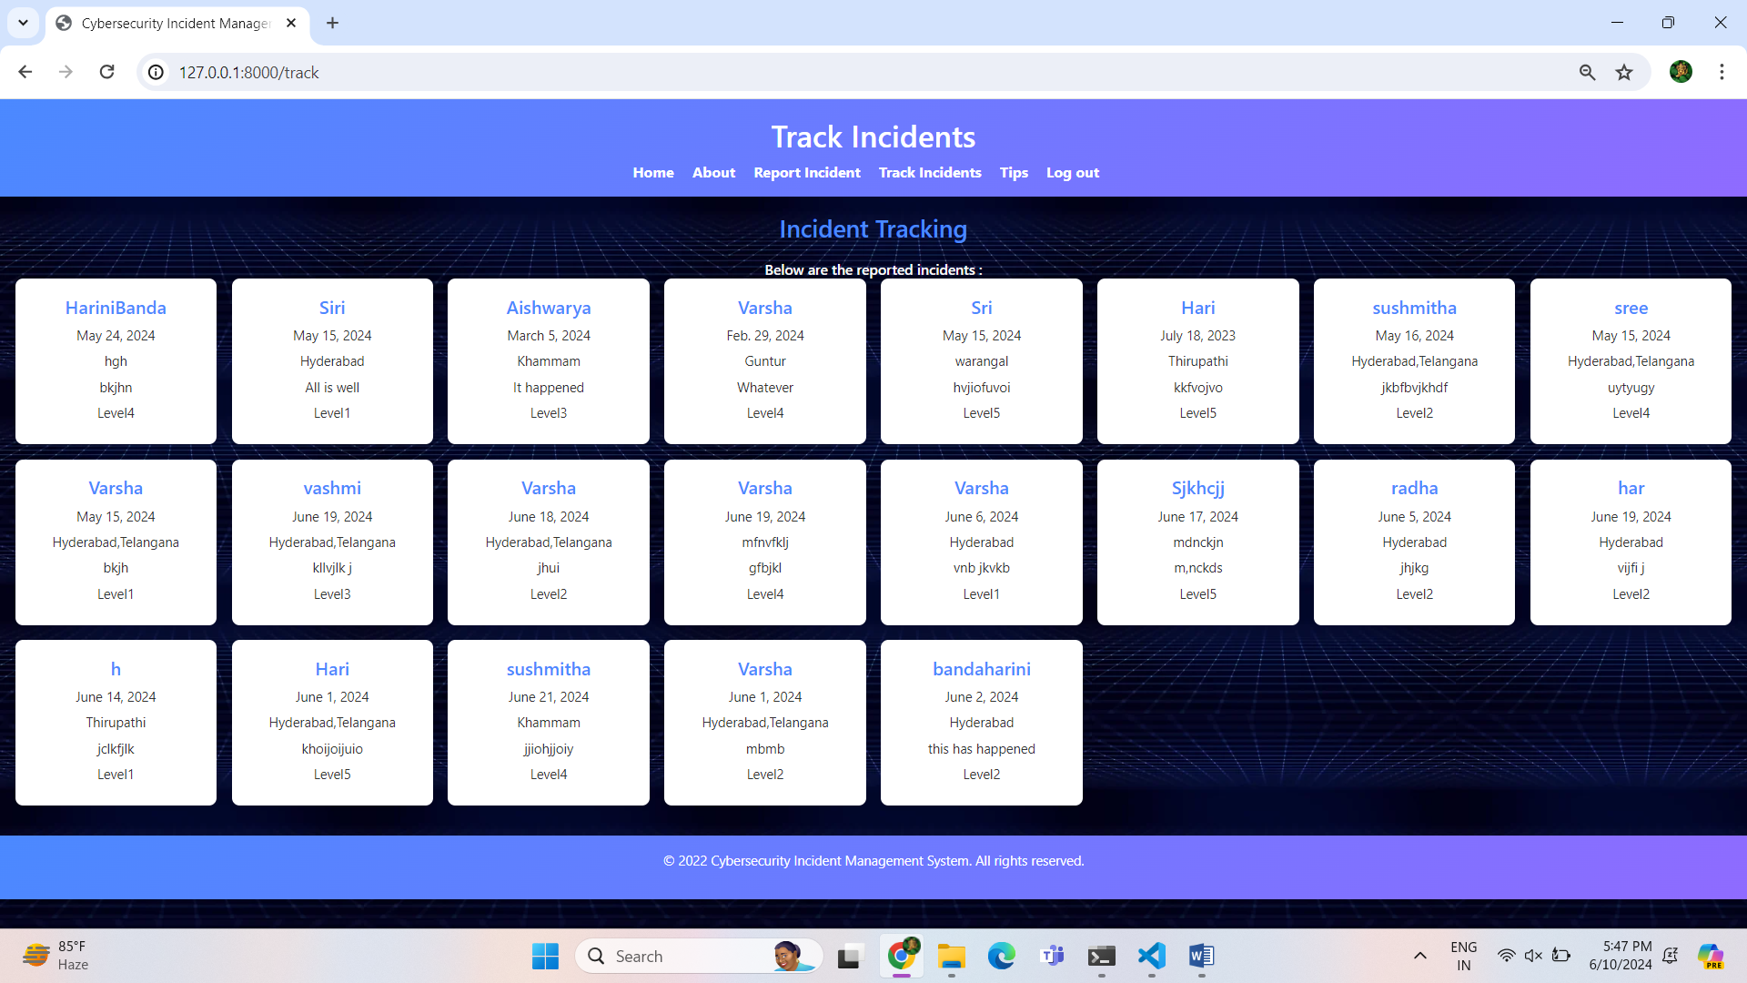

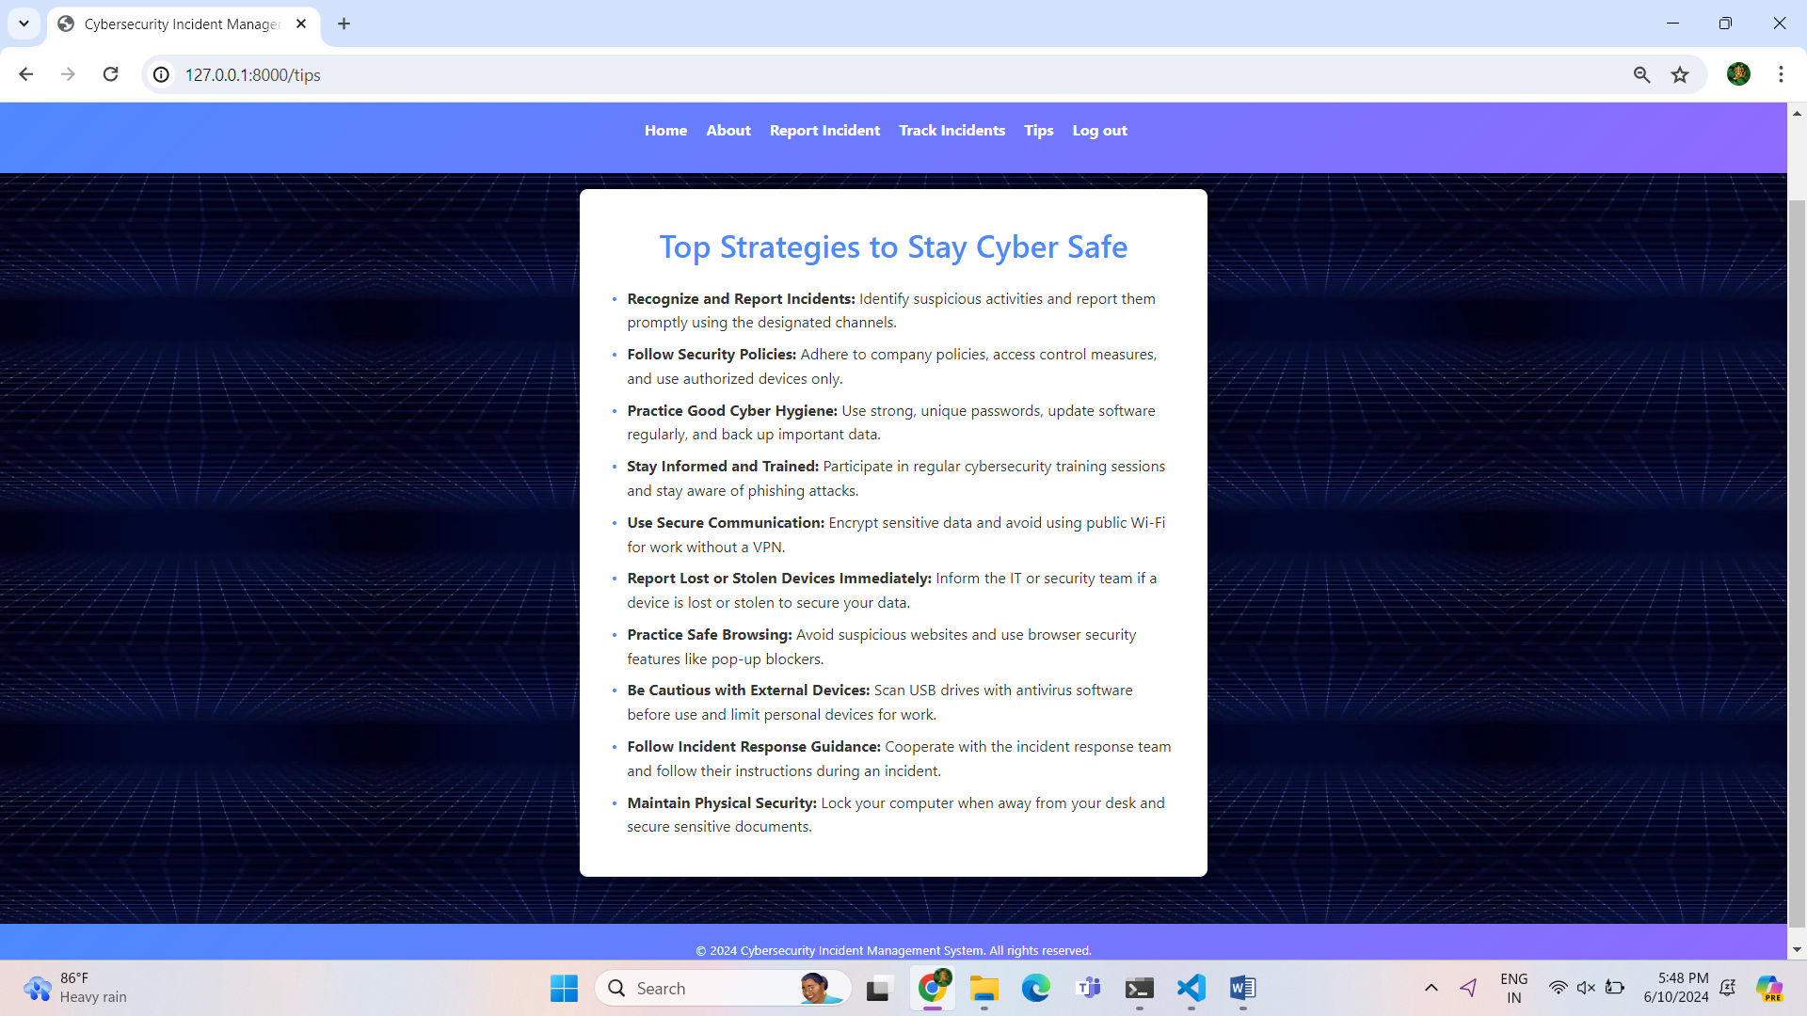

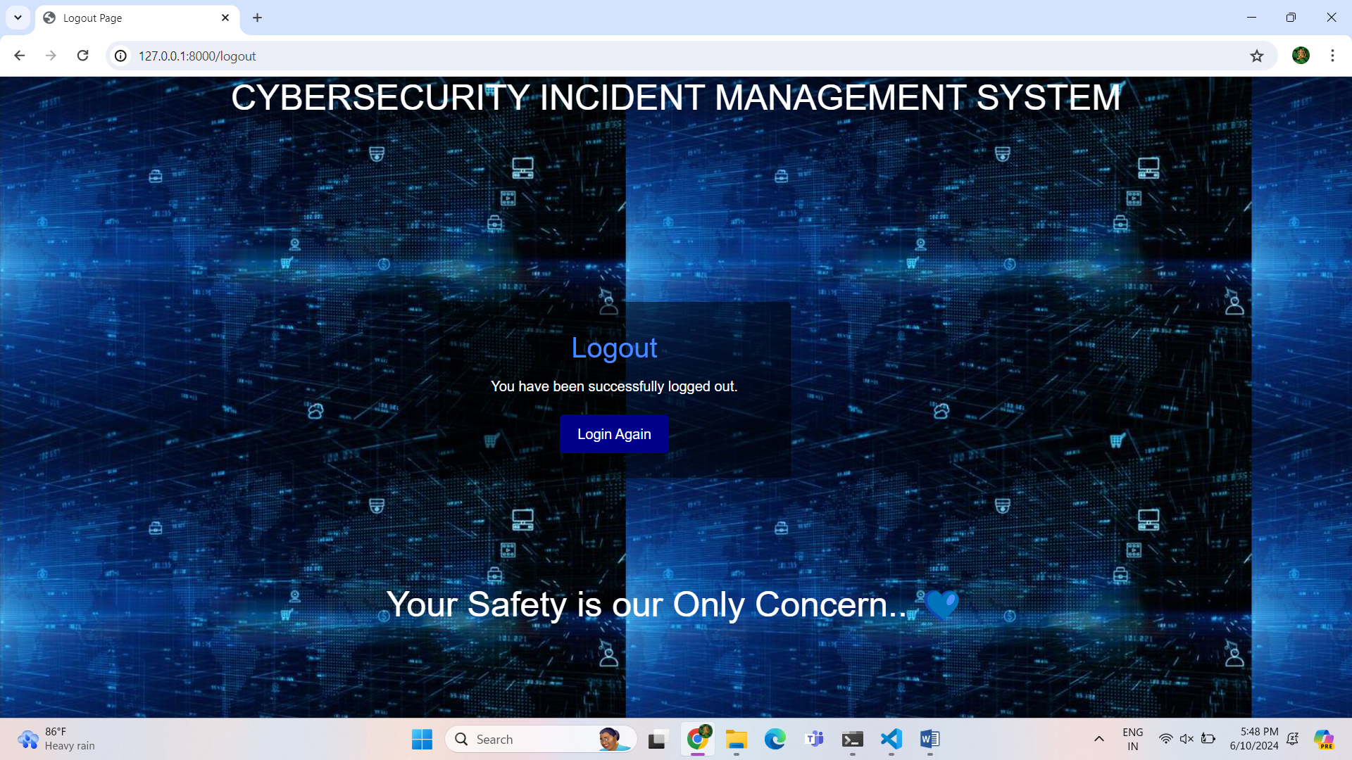

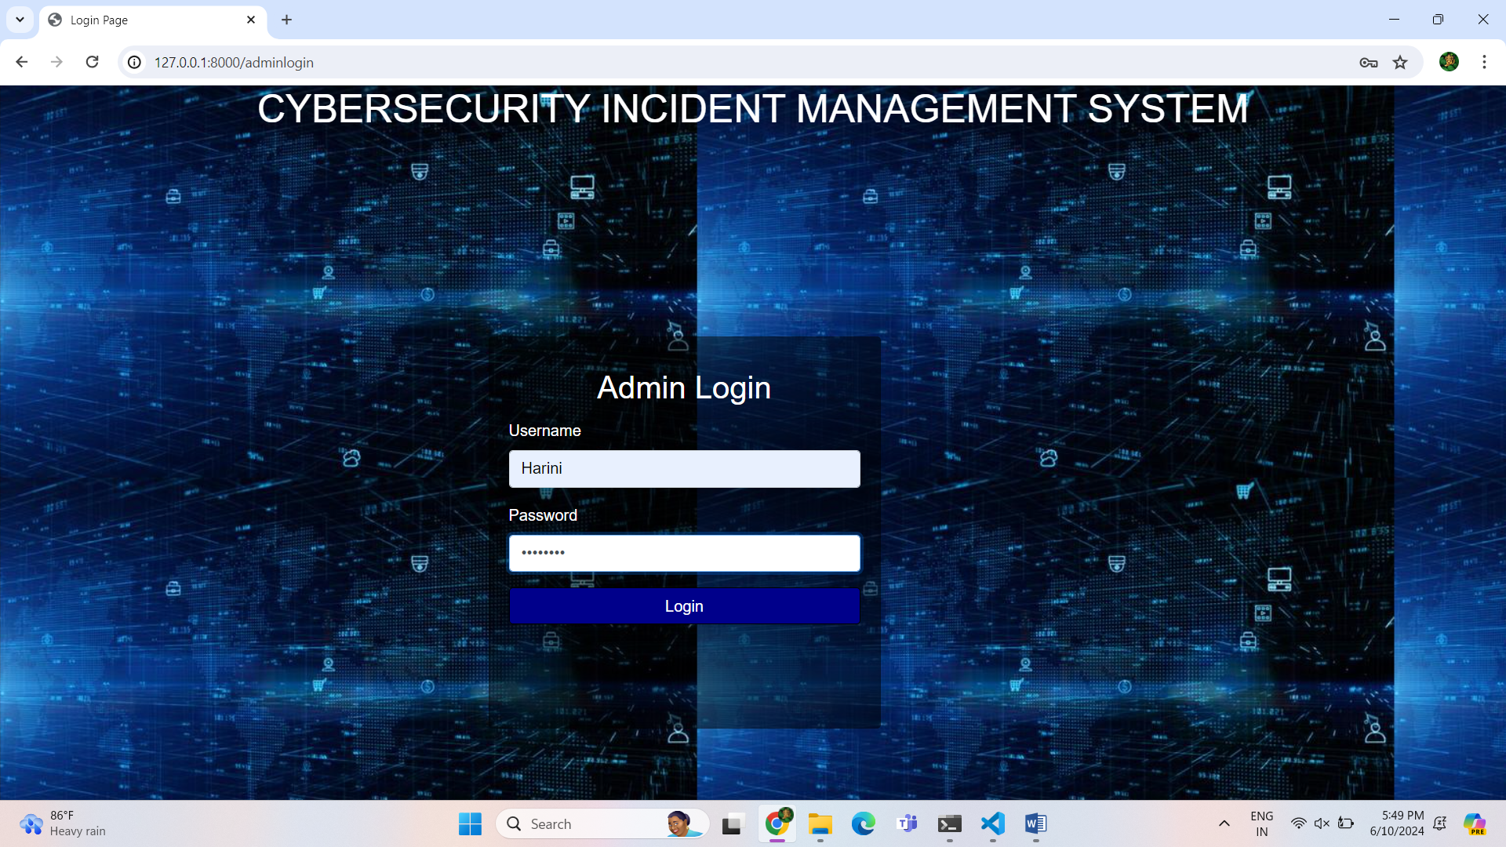

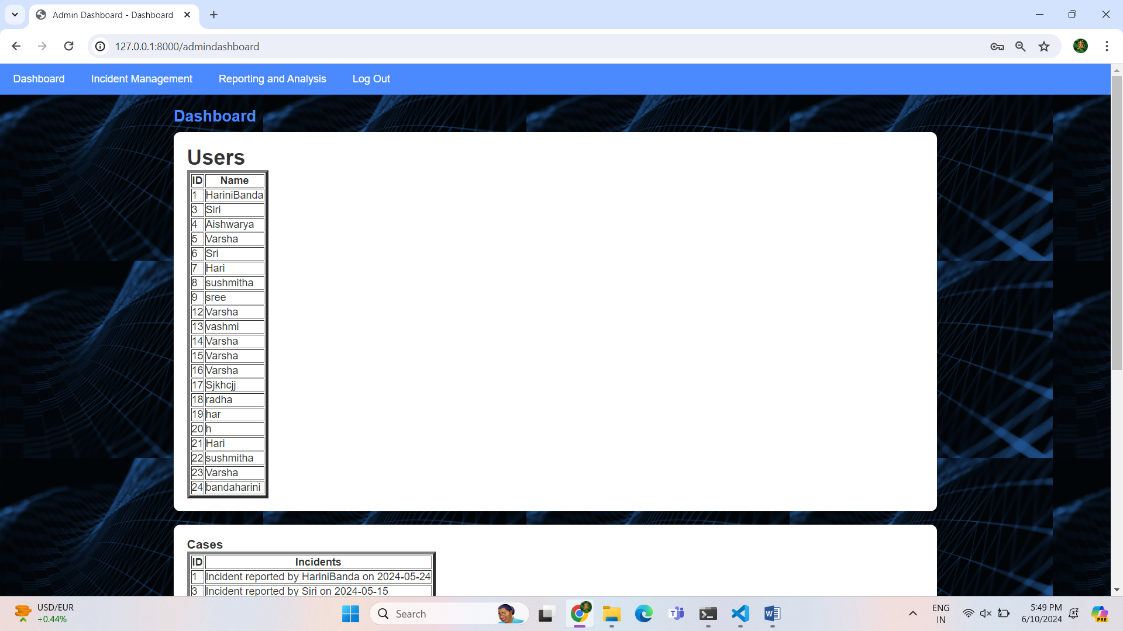

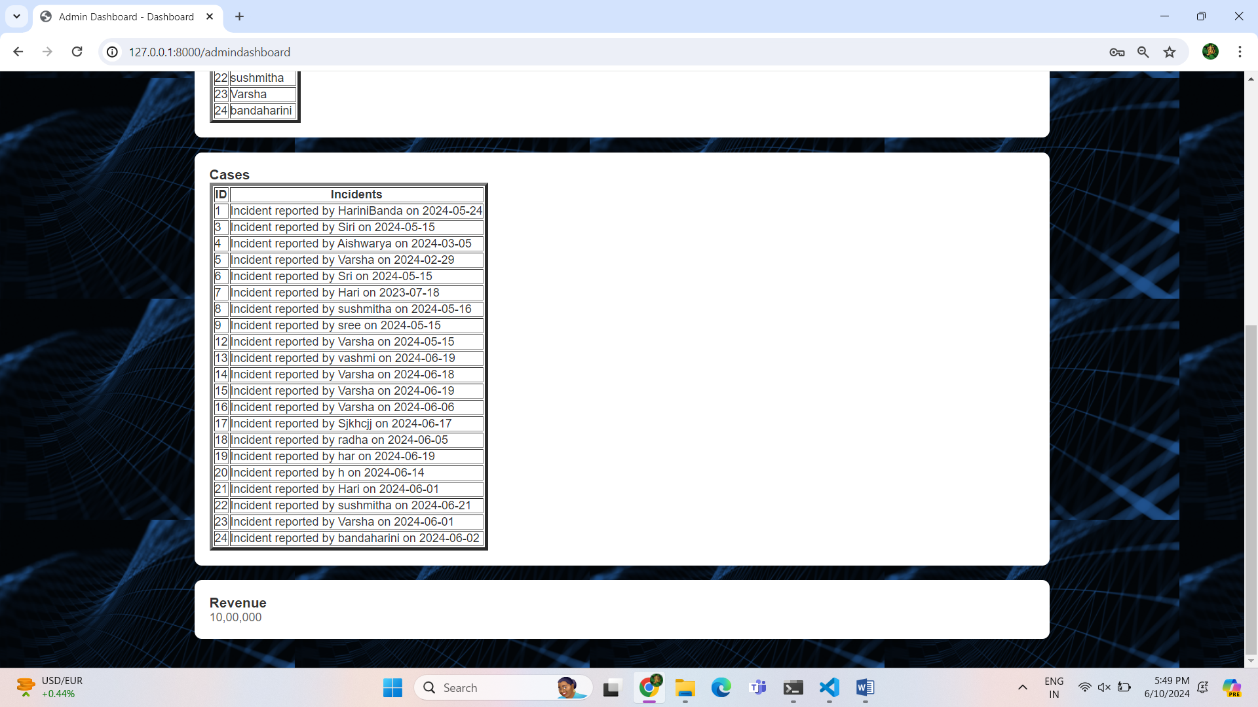

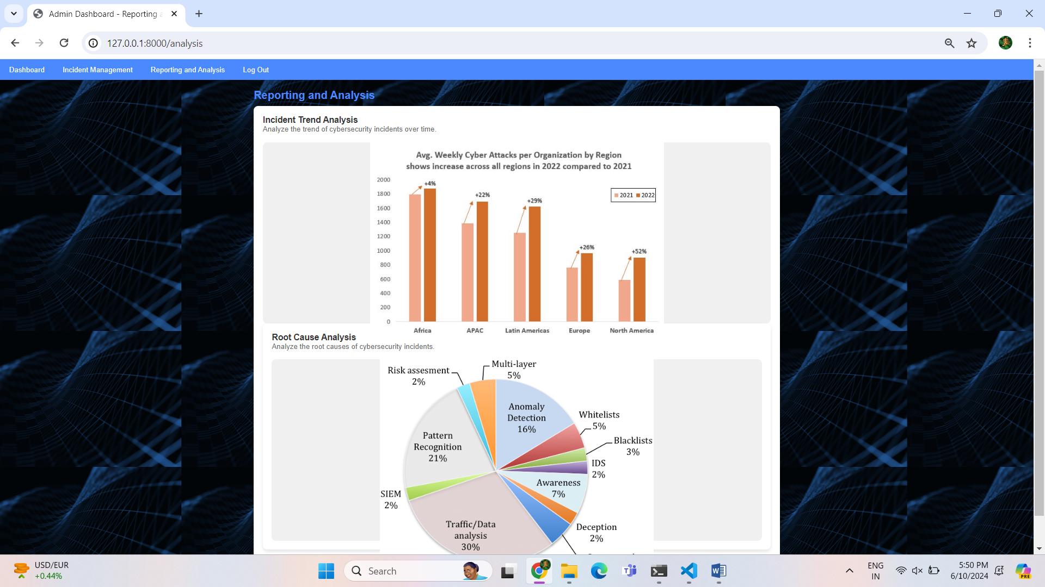

Future work:

Implementing the AI generator,search bar for incidents.

# References:

<https://www.geeksforgeeks.org/django-tutorial/>

<https://docs.djangoproject.com/en/5.0/>

<https://getbootstrap.com/>

<https://www.chartjs.org/>